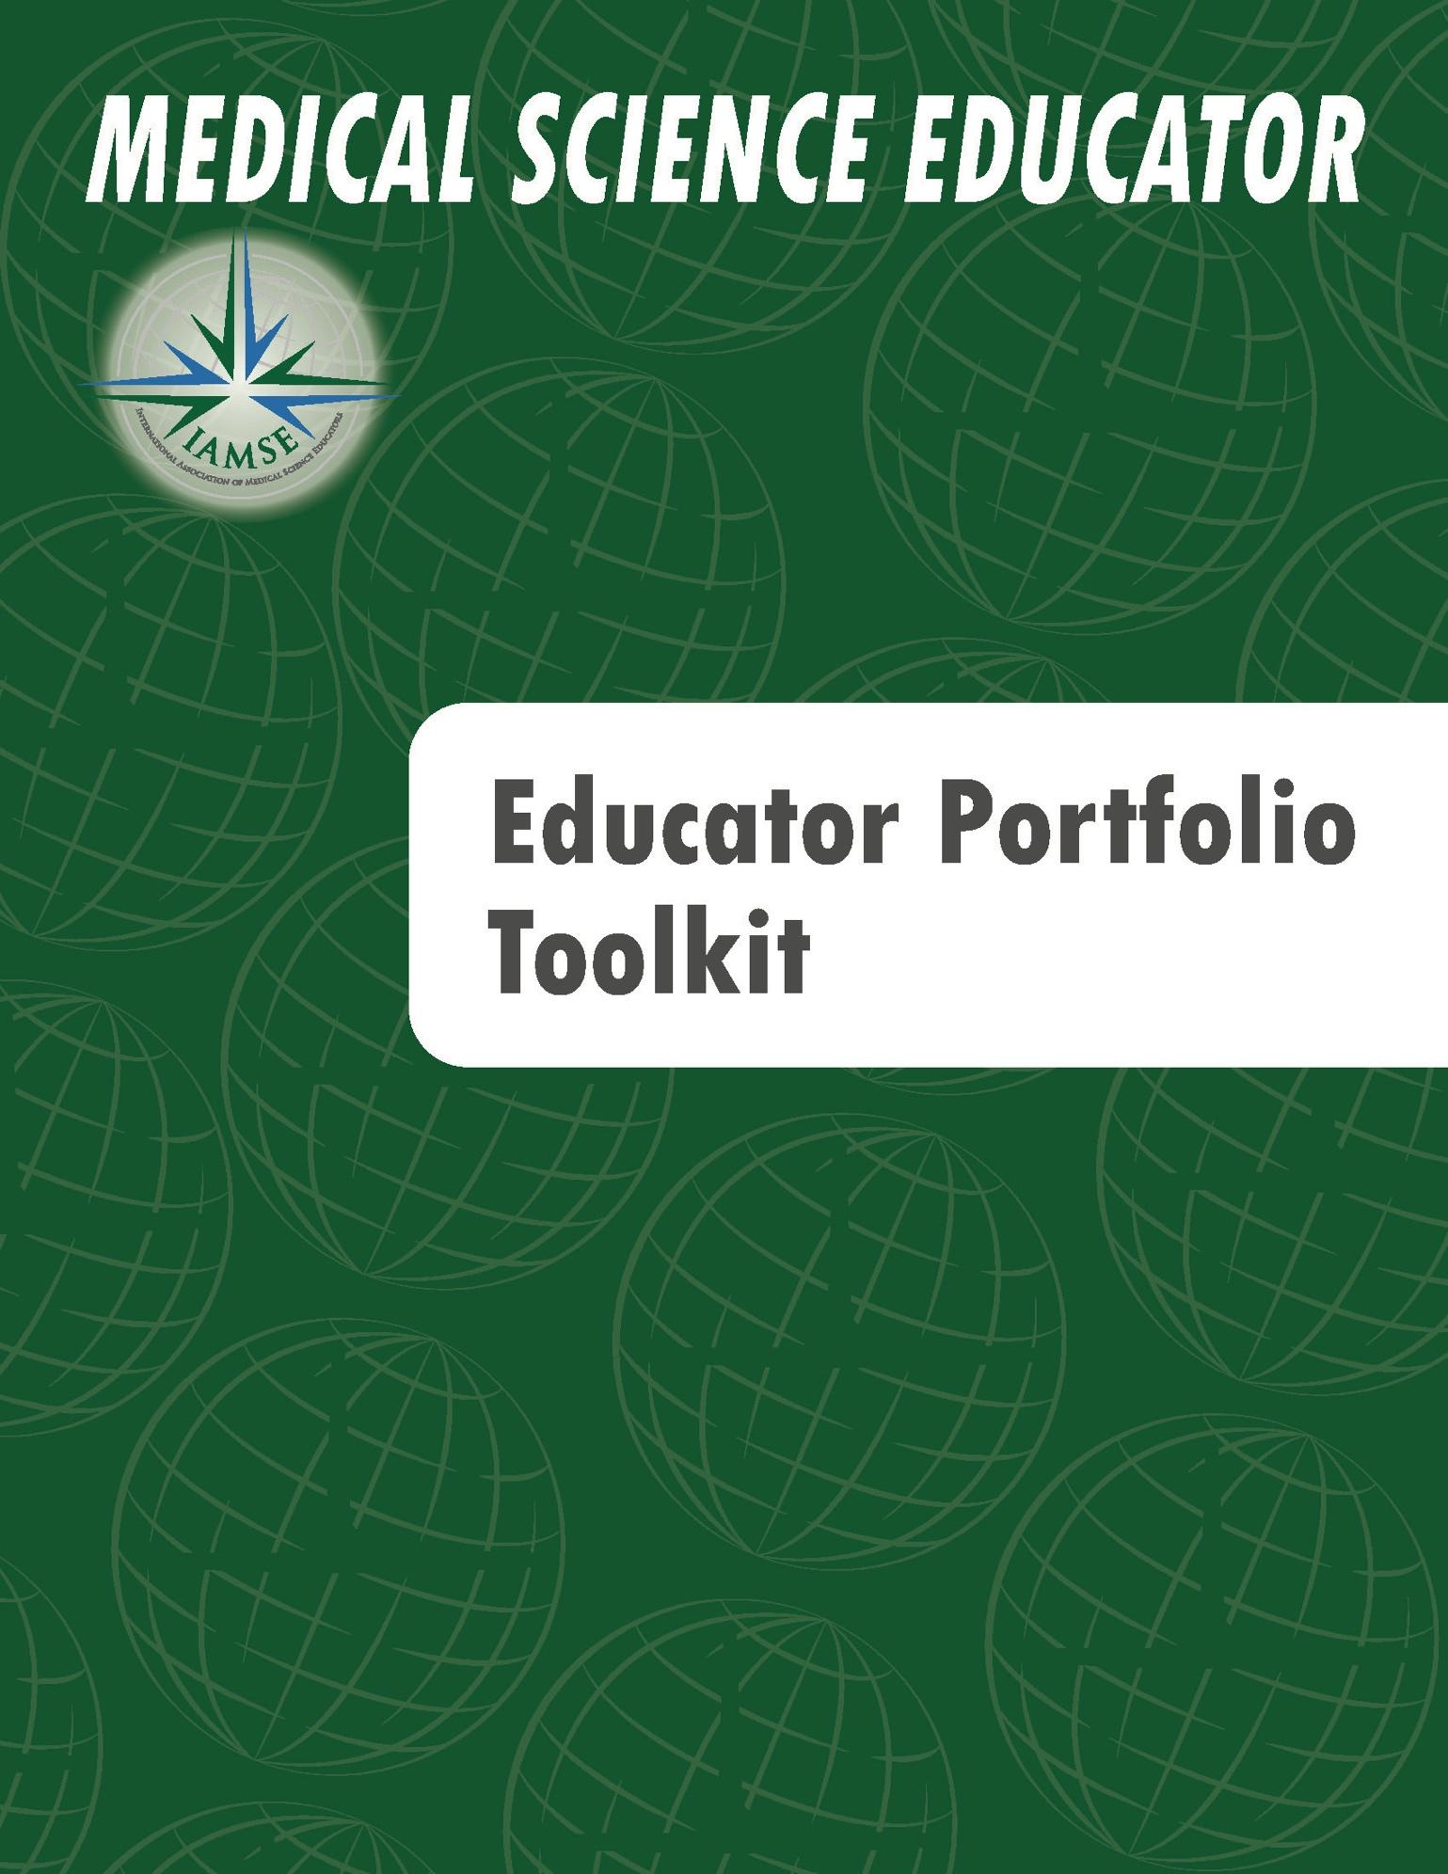
INTERNATIONAL ASSOCIATION OF MEDICAL SCIENCE EDUCATORS
MEDICAL SCIENCE EDUCATOR PORTFOLIO TOOLKIT

This medical science educator portfolio toolkit was created by the members of the Committee for the Advancement of Medical Science Educators (CAMSE), a subcommittee of the IAMSE Professional Development Committee (2019):

Bonny L. Dickinson, PhD, MS-HPEd (CAMSE co-chair)*
Mercer University School of Medicine

Nicole Deming, JD, MA (CAMSE co-chair)*
Case Western Reserve University School of Medicine

Lisa Coplit, MD
Frank H. Netter, M.D. School of Medicine at Quinnipiac University

Kathryn N. Huggett, PhD*
Robert Larner, M.D. Vermont College of Medicine at the University of Vermont

Kelly Quesnelle, PhD*
Western Michigan University Homer Stryker M.D. School of Medicine

Gary Rosenfeld, PhD
McGovern Medical School at the University of Texas Health Science Center at Houston

Maria Sheakley, PhD*
Western Michigan University Homer Stryker M.D. School of Medicine

Stephanie Wragg, PhD
California Health Sciences University College of Osteopathic Medicine

Approved by IAMSE February 2020
Updated August 2021*

The International Association of Medical Science Educators (IAMSE) serves medical science educators involved in basic science education and clinical teaching. Medical science educators may participate in one or more domains of educator activity as defined below:

- Teaching – Teaching is any activity that fosters learning. Educators may engage in teaching by giving lectures, facilitating small group discussions or lab groups, teaching on clinical rounds, etc. In this category, educators should document the quantity and quality of their teaching, a scholarly approach to the process of teaching, and any dissemination of work in the domain of teaching.

- Learner Assessment - Defined as all activities associated with measuring learners’ knowledge, skills, and attitudes. To assess excellence in this category, educators are asked to describe how they developed, implemented, analyzed, and synthesized an assessment project, including any dissemination of work in the domain of learner assessment.

- Curriculum Development – Curriculum development refers to the creation of a longitudinal set of educational activities and is thus differentiated from the creation of a single educational event. Examples may include a basic science lecture series, a set of clinical reasoning cases, a series of clinical skill workshops, faculty development workshops, etc. A curriculum must have goals, teaching methods appropriate for those goals, an informed approach to the design, a means of assessment of its effectiveness, and ongoing improvement based upon the evaluation results. In this category, the educator is asked to describe each of these aspects of the curricula they have developed, and any dissemination of work in the domain of curriculum development.

- Advising, Mentoring, and Coaching - An advisor helps an advisee in a focused capacity to help with a decision or course of conduct, or to provide suggestions for a specific project. A mentor helps a mentee to achieve personal and professional goals by providing guidance, support, and the creation of opportunities for the mentee. This requires an ongoing, committed relationship with clear goals to help the mentee achieve their own definition of success. A coach facilitates a short-term process that helps individual learners identify goals and the skills to achieve those goals through individual feedback and guidance. Assessing the quality of an educator’s contribution in this category means determining whether the advisor, mentor, or coach has helped the colleague or learner meet defined goals. In this category, the educator is asked to describe their role in facilitating colleague or learner success and asked to provide evidence of a scholarly approach to this important means of teaching. Dissemination of work in the domain of advising, mentoring, and coaching should also be described in this section.

- Educational leadership and administration - Effective leaders in education transform educational programs and advance the field. They develop a common language around issues related to race, racism, and more broadly diversity, equity, and inclusion. To assess excellence in this category, educators are asked to describe the initiatives they have led in their roles, the impacts and improvements their changes have made, and any dissemination of work in the domain of educational leadership and administration.

The worksheets presented on the following pages were designed to help educators evaluate and present their activities across these five educator domains, and were designed based on the principles of the Q² Engage model¹, highlighting the Quantity, Quality, and Engagement of each educational activity. The Q² Engage model was adopted as an organizing framework for the worksheets to provide quality metrics for evaluating excellence in each of the five educator domains.

These worksheets should be used to highlight a few of the educator’s most significant contributions, as this portfolio is intended to supplement a curriculum vitae as part of a promotion package.

The Description section of each worksheet is used to clearly describe the details of the activity, including the who, what, when, where, how often, and how much time is devoted to the activity. Relevant background should be provided in this section so that reviewers have sufficient context in which to assess the activity.

The Scholarly Approach section of each worksheet is used to illustrate the thoughtful and informed approach to the design and development of the educational activity. This should include evaluation and/or reflection on the activity, and ideally, improved outcomes.

The Scholarship/Dissemination section of each worksheet is used to demonstrate contributions to the larger educational community through peer-reviewed dissemination of the work. Dissemination of scholarship can take many forms. Contributing scholarship to the field of medical science education is important because it provides a platform for others to use as they engage in educational activities at their home institutions, and it is an excellent way to demonstrate an educator’s value as a representative of their home institution at times of promotion. In this section, educators should also address the rationale supporting selection of a particular venue for dissemination of their work.

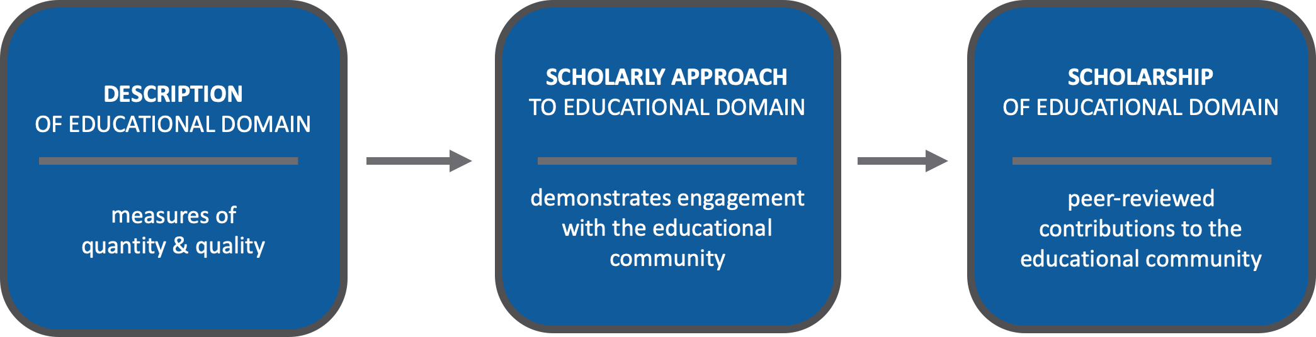

These worksheets are organized to illustrate a continuum of development of your educator activities from scholarly design to dissemination. They may be used as you prepare your educational portfolio for promotion, or as a form of self-reflection. The companion guide for evaluating educators using these worksheets is available on the IAMSE website, along with a sample set of completed worksheets.

References:
1. Simpson D, Fincher RM, Hafler JP, Irby DM, Richards BF, Rosenfeld GC, Viggiano TR. Advancing educators and education by defining the components and evidence of educational scholarship. Medical Education. 2007. (41) 1002-1009.

Additional Resources:
- Simpson D, Marcdante K, Fenzel J. The educator's portfolio & curriculum vitae - workshop & resource guide. MedEdPORTAL. 2007;3:677. https://doi.org/10.15766/mep_2374-8265.677
- AAMC Toolbox for Evaluating Educators. Gusic M et al. MedEdPORTAL
- Baldwin, C, Chandran, L, & Gusic, M. Educator evaluation guidelines. MedEdPORTAL, 2012. Available from:www.mededportal.org/publication/9072.
- Gusic M, Amiel J, Baldwin C, et al. Using the AAMC toolbox for evaluating educators: you be the judge! MedEdPORTAL. 2013;9:9313. https://doi.org/10.15766/mep_2374-8265.9313
- Gusic M, Chandran L, Balmer D, D'Alessandro D, Baldwin C. Educator portfolio template of the academic pediatric association's educational scholars program. MedEdPORTAL. 2007;3:626. https://doi.org/10.15766/mep_2374-8265.626
- Simpson D. et al. Advancing Educators and Education by Defining the Components and Evidence Associated with Educational Scholarship. Medical Education 2007;41:1002–1009.
- Bonny L. Dickinson, Nicole Deming, Lisa Coplit, Kathryn N. Huggett, Kelly Quesnelle, Gary Rosenfeld, Maria Sheakley, and Stephanie Wragg. IAMSE Member Perspectives on the Recognition, Reward, and Promotion of Medical Science Educators: An IAMSE Sponsored Survey. Medical Science Educator. 28(2): 335-343, 2018
- Leadership Lesson: The Educator Portfolio: A Tool for Career Development. By Constance D. Baldwin, Ph.D., Maryellen Gusic, M.D., and Latha Chandran, M.D., M.P.H.
- Association of American Medical Colleges (AAMC) Group on Educational Affairs Consensus Conference on Educational Scholarship. Advancing Educators and Education: Defining the Components and Evidence of Educational Scholarship; 2007.
- Glassick, C. E., M. T. Huber, and G. I. Maeroff. 1997. Scholarship Assessed, Evaluation of the Professoriate. An Ernest L. Boyer Project of the Carnegie Foundation for the Advancement of Teaching. Jossey-Bass. San Francisco. (Memorial Library Call Number: LB 2332 G63 1997 c.2).
- Nicole M. Deiorio, Patricia A. Carney, Leslie E. Kahl, Erin M. Bonura & Amy Miller Juve (2016) Coaching: a new model for academic and career achievement, Medical Education Online, 21 :1, 33480, DOI: 10.3402/meo.v21.33480
- Meg Wolff, Nicole M. Deiorio, Amy Miller Juve, Judee Richardson, Gail Gazelle, Margaret Moore, Sally A. Santen & Maya M. Hammoud (2021 ): Beyond advising and mentoring: Competencies for coaching in medical education, Medical Teacher, DOI: 10.1080/0142159X.2021.1947479
- Adrian K. Reynolds (2020) Academic coaching for learners in medical education: Twelve tips for the learning specialist, Medical Teacher, 42:6, 616-621, DOI: 10.1080/0142159X.2019.1607271
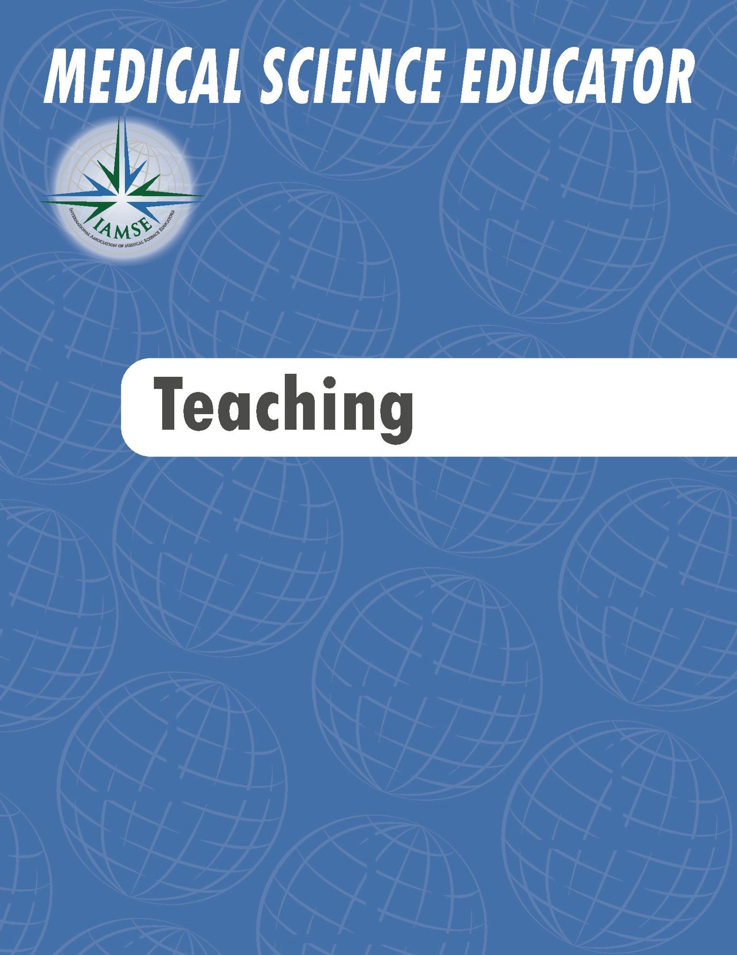
EXCELLENCE IN TEACHING
Instructions: Use this worksheet to reflect and collect examples of your own work. If your institution does not provide a portfolio template, this worksheet can be used to create your own portfolio. To complete, remove the sample text and fill with your own examples. This form may be used to describe a single example of teaching in great detail, or a series of related teaching sessions. These instructions can also be deleted at any time.

DESCRIPTION
TITLE OF LEARNING ACTIVITY  - Single session  - Series  - Other | - Principles of autonomic pharmacology lecture  - Diagnosis of periodontal diseases lecture  - Opioid overdose high-fidelity simulation  - Instructor-guided independent learning assignments on renal physiology
SETTING  - Course/Clerkship  - Certiﬁcate program  - Elective  - Faculty development  - Other | - Hematology and Oncology Course  - Master of Science in Biomedical Sciences Program  - Neuroanatomy Elective  - Introduction to Professional Nursing Course  - Periodontology Introduction Course  - Faculty Development Workshop Series
TARGET LEARNERS  - Type of learner  - Level of learner  - Other | - First year pharmacy students and third year medical students (interprofessional education)  - Second year nursing students  - Dental students in the first and second year  - Internal Medicine residents in post-graduate years one and two  - Faculty educators at any rank
MY TEACHING ROLE(S)  - Facilitator  - Instructor  - Invited presenter  - Learning objective author  - Other | - In addition to facilitating the event, I was responsible for creating learning objectives, designing the session and submitting exam questions.  - I facilitated a case session.  - I was part of an interprofessional team who worked together on the design and facilitation of this session.  - I was invited to present a faculty development workshop outside of my home institution, which involved coordinating learning objectives, creating and delivering content, and designing post-session knowledge assessments.
DESCRIPTION (cont.)
CONTACT WITH LEARNERS  - Number of learners per session  - Direct contact time per session  - Number of sessions per year  - Number of years teaching  - Other | - I have taught this three-hour session to 84 students annually for the past four years, reaching a total of 336 learners.  - I teach five unique one-hour sessions in this course. Approximately 20 students attend each session and I have been teaching this course for eight years.  - I have facilitated two PBL groups per course for the past five years. The course runs twice per year, and there are about nine learners per session.  - Each session meets twice per week for four weeks and the number of participants ranges from 15-50.
MY GOALS ADDRESS  - Teaching or learning environment  - Instructional methodology  - Instructional materials  - Content delivery  - Other | - My goal was to create clear, concise, and highly pertinent learning materials for the students in my sessions.  - My goal was to use active learning methodologies to introduce the learners to other health science professionals and improve their attitudes about interprofessional teamwork.  - My goal was to improve inclusivity and reduce bias in my instructional materials.
SCHOLARLY APPROACH
INFORMED PREPARATION  - Consulted literature  - Reviewed instructional texts  - Attended faculty development session  - Attended webinar  - Other specialized training  - Grant funding  - Other | - I read an active learning manual and reviewed the current literature on active learning methodologies for teaching physiology. I also attended a session on active learning and the flipped classroom at the IAMSE annual meeting.  - I attended TBL 101 at the IAMSE annual meeting last year.  - I attended a series of faculty development sessions run by our teaching academy to earn a certificate in PBL facilitation.  - I was awarded a foundation grant to develop this instructional series.
DEVELOPMENT OF OBJECTIVES AND INSTRUCTIONAL METHODS  - Developed learning objectives that are clear, at an appropriate level for learners, and aligned with institutional/program goals  - Selected teaching methods that align with learning objectives  - Other | - I modified my learning objectives based on the American Society of Hematology learning objectives, and I created case-based learning sessions for the application of pharmacotherapeutics.  - I selected TBL as an instructional method to improve learner experience working in teams during the first semester.
SCHOLARLY APPROACH (cont.)
OUTCOMES AND EVALUATIONS  - Learner evaluations  - Learner outcomes  - Peer review  - Expert review  - Teaching awards  - Other | - I have attached learner comments from the past three years, showing improved student satisfaction using this approach.  - I received a teaching award from my peers for this work.  - Standardized examination (board) scores increased by 0.5 standard deviations after implementation of this course.  - I engaged in our institutional peer review process and incorporated the received feedback to improve my instruction.  - I used learner feedback to revise the sequencing of the course. This change correlated with a 5% increase in student performance on the summative course exam relative to the past 3 years.
MY REFLECTIVE CRITIQUE  - Reviewed recording  - Reviewed peer evaluations  - Reviewed learner evaluations  - Kept a written journal  - Peer consultation  - Future directions  - Other | - After reviewing the session recording, as well as peer and student evaluations, I have decided to move one component of the session into the pre-session preparation materials to provide participants with more time during the session to engage with peers.  - Based on my notes following the session, I could benefit from learning additional facilitation techniques for TBL. I am planning on attending “Facilitating your TBL” at AMEE this summer.
SCHOLARSHIP/DISSEMINATION
DISSEMINATION  - Peer-review  - International  - National  - Regional/Local  - Invited dissemination  - International  - National  - Regional/Local  - Dissemination Type  - Publication  - Oral presentation  - Poster presentation  - Scholarship metrics such as cites, downloads, presentation evaluations are available  - Other | - I submitted this simulation exercise to MedEdPORTAL because this is a journal of teaching and learning resources for AAMC members that has a wide readership. It is currently under review.  - I authored a paper describing our intervention and the change in student’s attitudes and perceptions. This work was recently published in a peer-reviewed journal targeting pharmacy educators.  - This work was presented at the IAMSE annual meeting in order to reach both PA program educators and nursing educators.  - I was invited to teach a similar workshop at my national specialty meeting, and then invited to another university to present a faculty development seminar on the topic.

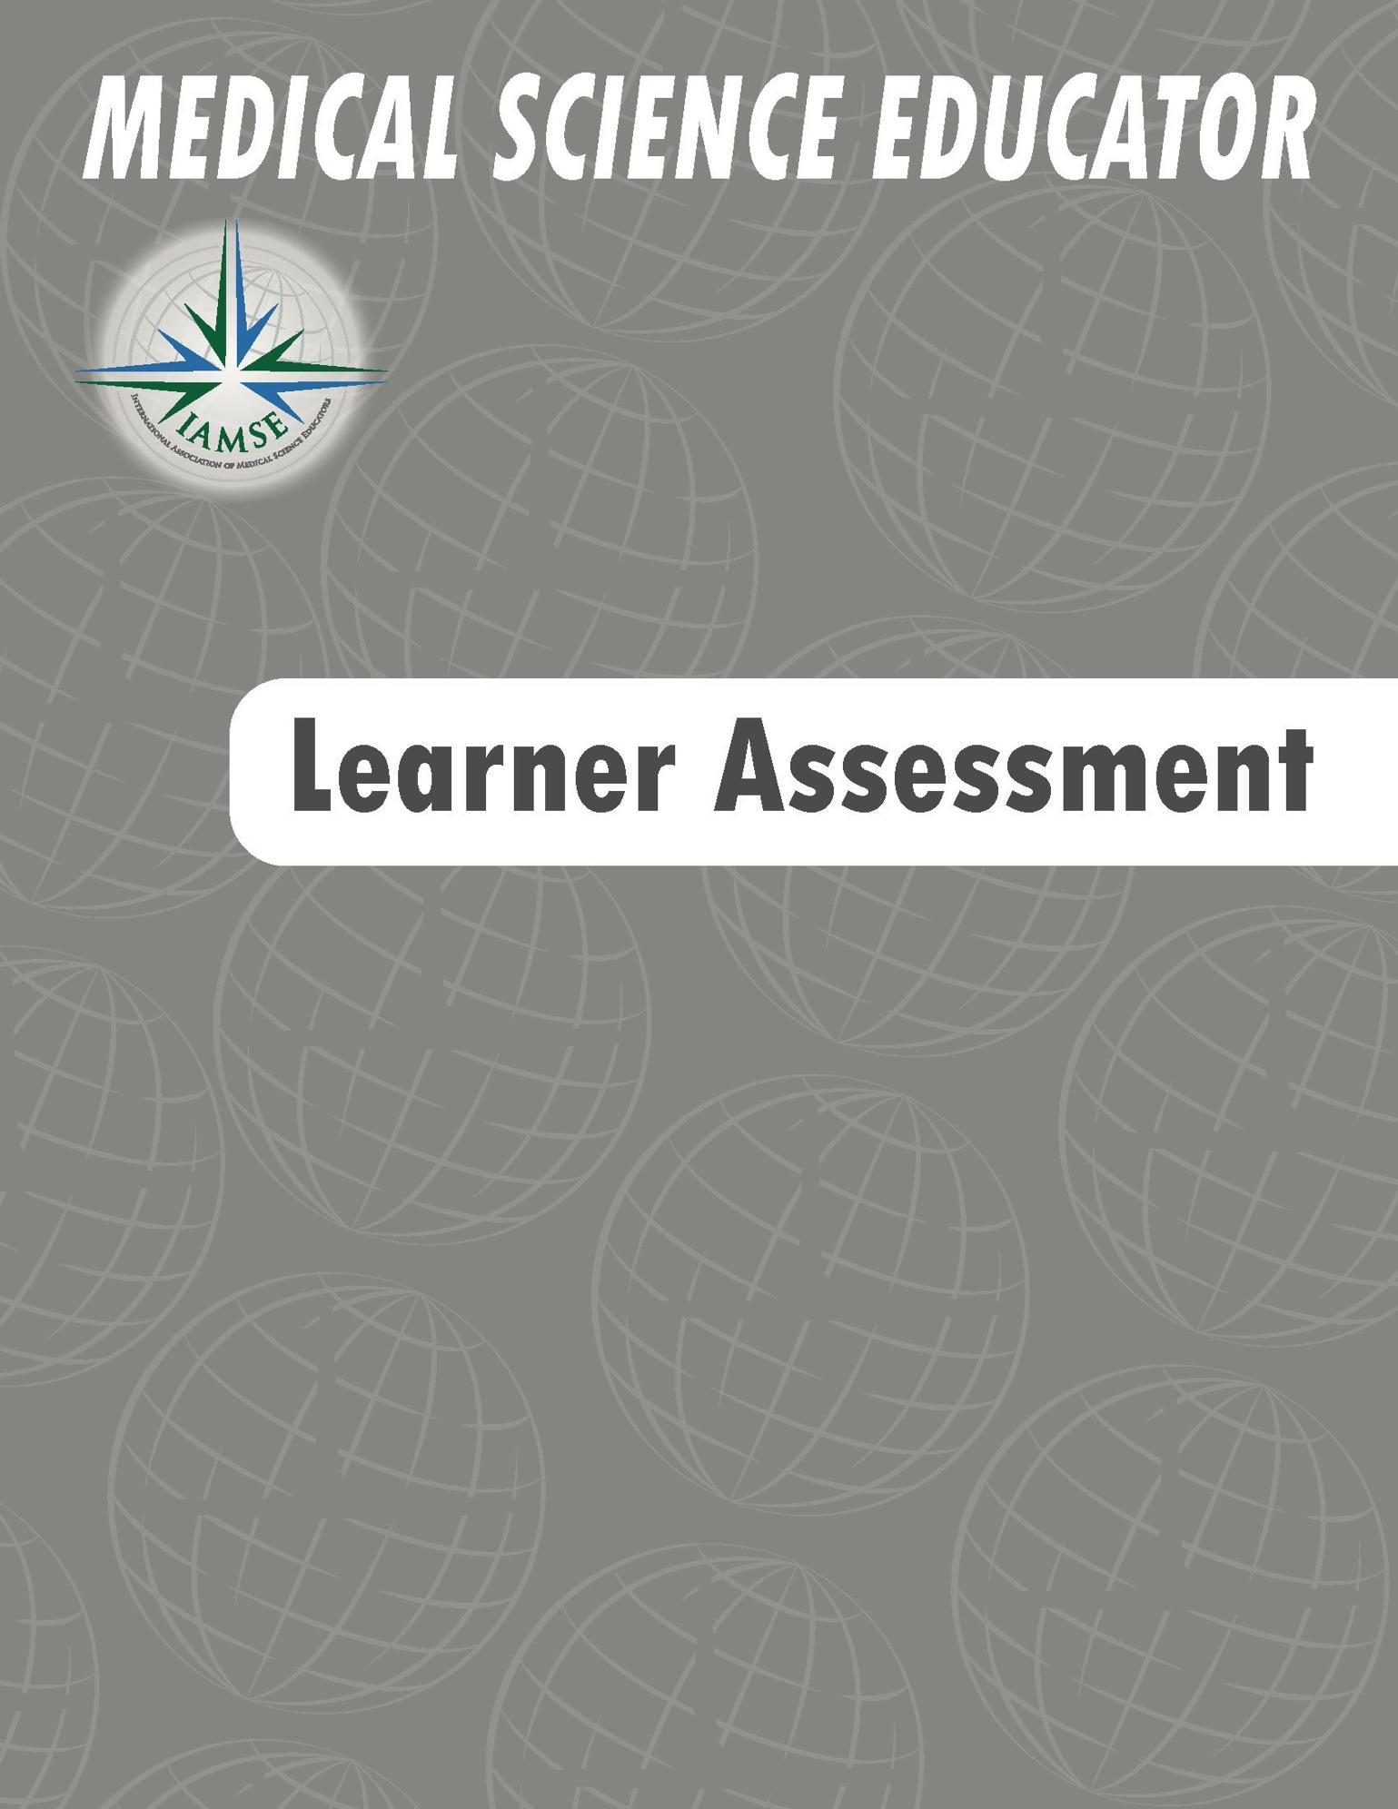
EXCELLENCE IN LEARNER ASSESSMENT
Instructions: Use this worksheet to reflect and collect examples of your own work. If your institution does not provide a portfolio template, this worksheet can be used to create your own portfolio. To complete, remove the sample text and fill with your own examples. This form may be used to describe a single example of learner assessment in great detail, or a series of assessments. These instructions can also be deleted at any time.

DESCRIPTION
ASSESSMENT TYPE(S)  - Summative assessment(s)  - Formative assessment(s)  - Vignette-style multiple choice questions (MCQ)  - Other multiple-choice questions (MCQ)  - Open-ended questions  - Group project  - OSCE  - Clinical skills/direct observation  - Readiness Assurance Test (RAT)  - Data analysis  - Other | - MCQs for summative exam at the end of a course  - RAT assessment for Team-based learning  - Group project assessment  - Clinical skills assessment of the cardiac exam during the cardiology course  - Assessment of heart auscultation using a manikin  - OSCE at the end of the Internal Medicine clerkship
SETTINGS  - In-person  - Hybrid  - Virtual  - Course/clerkship  - Certificate program  - Elective  - Other | - M2 level Cardiology Course  - Master of Science in Biomedical Engineering  - Anatomy elective for Physician Assistant students  - Internal Medicine Residency Program  - Family Medicine Clerkship
TARGET LEARNERS  - Type(s) of learner  - Number of learners  - Level of learner  - Other | - First year pharmacy students and third year medical students (interprofessional education)  - Second year nursing students  - Second year dental students  - Internal Medicine residents  - Faculty educators  - Family Medicine clerkship students

DESCRIPTION (cont.)
MY ROLE(S) IN ASSESSMENT  - Clerkship director  - Course director  - Discipline/thread/strand director  - Faculty member  - Peer/colleague  - Committee member  - Project manager  - Other | - I was responsible for creating 10 higher-order NBME-style assessment questions for the cardiology course summative exam.  - I was part of an interprofessional team who worked together to write integrated assessment questions for an IPE elective course.  - I was responsible for designing an open-ended assessment with a grading rubric for a septic shock simulation session.  - As the cardiology course director, I edited examination questions to improve them from recall to higher-order questions.  - I was the Director of Clinical skills and created an authentic space for learning and assessing clinical skills.  - I have been appointed/elected to serve on the department/school/university committee to incorporate diversity, equity and inclusion (DEI) metrics into the faculty annual review and promotion criteria.
MY GOAL  - Create new assessments  - Improve existing assessments  - Review assessment data  - Design an appropriate assessment space/environment  - Other | - To create clear, concise, clinically relevant MCQs with good discrimination for my course content.  - To improve existing assessment questions that had poor discrimination.  - To review all of the assessment items on the course exam to identify which items tested recall of factual information and rewrite those items to focus on application and synthesis of knowledge.  - To build an exam consisting of 60% clinical vignettes, 20% data analysis, and less than 20% recall questions.  - To design an authentic clinical space for assessing student mastery of clinical skills.  - To use learning analytic software and technology to facilitate real-time diagnostic assessment.
SCHOLARLY APPROACH
INFORMED PREPARATION  - Reviewed current assessment(s)  - Aligned assessment with objectives, competencies, or entrustable professional activities  - Purpose of assessment was made clear to learner  - Blueprinted the assessment  - Assessment type is appropriate for construct it measures  - Consulted literature  - Reviewed texts or handbooks  - Attended faculty development session  - Attended webinar  - Attended conference  - Other specialized training  - Other | - I read the NBME-style question writing manual and used it as a guide for writing NBME style questions for the course summative exam.  - I attended an MCQ item writing session at the IAMSE annual meeting.  - I attended a series of faculty development sessions run by our teaching academy on question writing and item analysis and used that information to identify items on my course exam that needed improvement.  - I consulted colleagues at another institution to discuss ways in which they ensure alignment of course summative examination questions with the course learning objectives.  - I used the Kirkpatrick Model to evaluate the effectiveness of my clerkship program.  - I worked with an architect with expertise in hospital design to create an authentic space for learning and assessing clinical skills.  - I completed 360, personal coaching, to align professional and personal development to incorporate feedback for more inclusive and diverse literature into processes.
DEVELOPMENT OF ASSESSMENT ITEMS OR TOOLS  - Developed assessment questions that are clear, at an appropriate level, and aligned with learning objectives  - Developed clinically relevant assessment questions | - I wrote two new assessment questions for each of my teaching events in the immunology course that align with the learning objectives for the event and which test the basic science content underlying clinically relevant concepts at an appropriate level for learners.  - I worked with a clinician colleague to revise my basic science exam questions to include clinical vignettes.  - I worked with a software engineer to create a web-based assessment.
OUTCOMES AND EVALUATIONS  - Assessment item analysis  - Peer review/evaluation  - Content expert review  - Other | - I have included a table showing the item analysis of my exam questions and how I have improved the items over the course of three years.  - I sought peer-review of my exam questions from a content expert from another institution to improve the quality and clinical relevance of my exam questions in the renal course.  - I modified my questions in the exam bank to increase the number of clinical vignette items for each session to at least 50% of the total items.  - I used data analytics software to evaluate student performance data gathered from a novel web-based assessment.
MY REFLECTIVE CRITIQUE  - Reviewed exam statistics  - Reviewed course director feedback from exams  - Reviewed student feedback  - Peer consultation  - Other | - Following each exam, I reviewed the exam statistics for each of my questions and identified those that could be improved, setting a deadline to make those improvements and following through on the improvement.  - I regularly use student comments and feedback to improve exam items in my test bank.  - I used analytics software data to identify performance gaps and to provide individualized training to students based on the assessment data.

SCHOLARSHIP/DISSEMINATION
DISSEMINATION  - Peer-review  - International  - National  - Regional/Local  - Internal peer review only  - Invited dissemination  - International  - National  - Regional/Local  - Dissemination Type  - Publication  - Oral presentation  - Poster presentation  - Scholarship metrics such as cites, downloads, presentation evaluations are available  - Other | - I created a network to share high-performing exam questions with colleagues from other institutions.  - I presented my methods for improving discrimination on exam questions and the resulting question performance data at the annual IAMSE meeting.  - I co-authored a paper on improving high-stakes assessments in medical education, which was published in Medical Science Educator, a peer-reviewed journal.  - I was invited to teach a question writing workshop at my national specialty meeting.  - I was invited to present a faculty development workshop on assessment at another university.

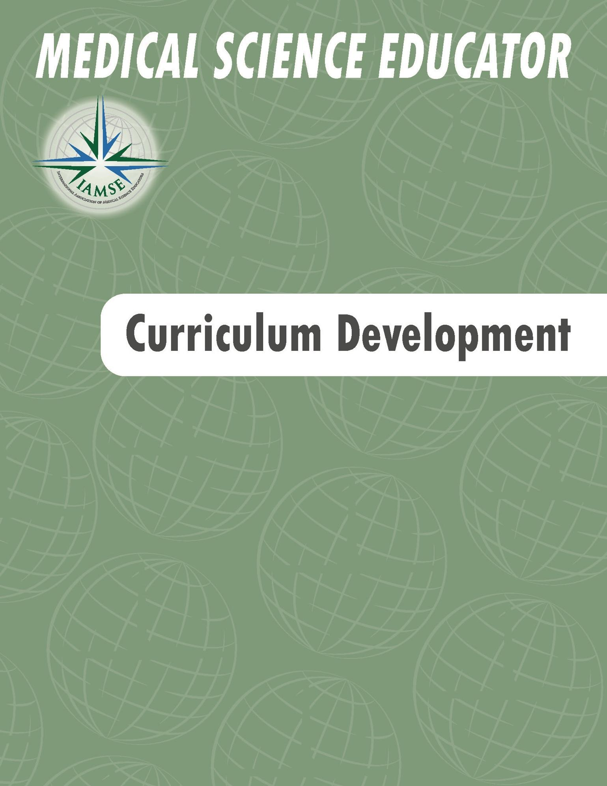
EXCELLENCE IN CURRICULUM DEVELOPMENT
Instructions: Use this worksheet to reflect and collect examples of your own work. If your institution does not provide a portfolio template, this worksheet can be used to create your own portfolio. To complete, remove the sample text and fill with your own examples. Although we have provided multiple examples below, it is recommended that you identify 1-3 items to describe as an example(s) of a curricular element in great detail. These instructions can also be deleted at any time.

DESCRIPTION
TYPE OF CURRICULAR ELEMENT OR SESSION  - Program  - Course/clerkship  - Elective  - Session(s)  - Other | - Renal system course for medical school  - Master of science in biomedical science  - Specific biomedical science discipline within an integrated medical curriculum  - Immunology discipline within an integrated medical curriculum  - Pharmacology case review series book  - Fellowship program in a national society  - National basic science curriculum
SETTING  - In-person  - Hybrid  - Virtual  - Course for degree program  - Discipline for degree program  - Certificate program  - Professional society  - Book or other publication  - Standardized curriculum  - Other | - Hematology and oncology course for medical school  - Master of science in biomedical science  - Immunology discipline within an integrated medical curriculum  - Dental school elective: infectious diseases  - Textbook on biochemistry in human medicine  - Objectives of Society/Organization Standardized Curriculum (e.g., Aquifer©, ScholarRx©, SketchyMedical©, Pathoma©, Osmosis©)
TARGET LEARNERS  - Type of learner  - Level of learner  - Other | - First year pharmacy students and third year medical students (interprofessional education)  - Second year nursing students  - Dental students  - Internal Medicine residents  - Faculty educators
MY ROLE  - Developer  - Advisor  - Editor  - Content curator  - Other | - I was the course co-director, responsible for developing course objectives and editing all course content.  - I was a member of the faculty advisory panel for this project.  - I was the editor of this textbook.  - I reviewed content and curricula developed by international experts in the field of Interprofessional Education to select, sequence, and deliver an IPE certificate program for medical students and nursing students.  - I served on an NSF grant advisory group.
DESCRIPTION (cont.)
NUMBER OF LEARNERS IMPACTED  - Number of learners per year  - Number of years involved  - Number of hours per year  - Other | - I developed a pharmacology curriculum for 235 nursing students that has been implemented for the past seven years.  - For the past two years, I have served as the director of the interprofessional education (IPE) curricular task force that created six IPE events annually for 100 medical students, 75 pharmacy students, and 60 nursing students.  - This book is geared toward students in health professions and it has sold over 20,000 copies in its first edition.  - This core curriculum is available to all 200 faculty educators of the national physiology society.  - I developed a longitudinal Humanism in Medicine course for 55 medical students 2015-present (20 curricular hours/year).
MY GOAL  - Create new curricular element  - Improve existing curricular element  - Review curricular element  - Other | - My goal was to review the course that prepares students for matriculation to medical school.  - My goal was to improve the discipline and its associated events, in order to prepare the students to obtain a score at or above the national average on their licensing exam while also preparing them to meet minimal competency standards prior to entry into clinical rotations.  - My goal was to develop a set of learning objectives for use by therapeutics faculty in pharmacy schools.  - My goal was to design a series of online anatomy cases for use by medical school faculty who are members of the society.  - My goal was to create a students-as-teachers certificate program for medical students.
SCHOLARLY APPROACH
INFORMED PREPARATION  - Identified and described knowledge gap  - Consulted literature  - Reviewed instructional texts  - Attended faculty development session  - Attended webinar series  - Other specialized training  - Grant funding  - Other | - After attending a session at AMEE last year about the integration of clinical problem-solving skills with basic science materials, I developed a series of case sessions for my course to improve the lower-than-anticipated level of competency for students entering the clinical years.  - In an effort to improve student evaluation of the course, I read the IAMSE Active Learning manual and designed a series of flipped classroom sessions to be used throughout the curriculum.  - Learning objectives for the discipline were created in alignment with the Pharmacology Knowledge Objectives and the material in the COMLEX content outline.
SCHOLARLY APPROACH (cont.)
DEVELOPMENT OF OBJECTIVES  - Clear  - Measurable  - Appropriate level  - Based on learner needs  - Integrated with other curricular components  - Aligned with institutional/program goals  - Aligned with national curricula  - Other | - I modified my learning objectives based on Canadian Association for Anatomy, Neurobiology, and Cell Biology learning objectives, and I created case-based learning sessions for the application of basic science knowledge.  - I conducted a Delphi study with leading experts to develop the objectives for a Professionalism in Medicine course.
DESIGN OF INSTRUCTIONAL METHODS  - Teaching and assessment are aligned with learning objectives  - Innovative  - Interactive  - Evidence-based  - Monitors learner progress and facilitates personalized learning  - Includes technology  - Promotes independent study or self-directed learning  - Other | - Course materials were innovative because they included a mix of didactic lecture, labs, Team-based learning events, and asynchronous electronic modules.  - In an effort to make electronic modules interactive and develop a relationship between teacher and learner, videos were included in each module.  - Created an assessment blueprint mapped to course learning objectives.  - Used software platform analytics to provide real-time feedback to learners.
OUTCOMES AND EVALUATIONS  - Employs multiple data sources  - Learner outcomes  - Learner evaluations  - Peer review  - Expert review  - Other | - This course has received learner ratings of satisfactory to outstanding every year since its inception. In addition, student performance has increased on national examinations since implementing this new curriculum.  - Students scored higher in the discipline of genetics on their board exam than any other discipline in our program last year.  - The students-as-teachers program resulted in a 25% increase in the number of our graduating students who were awarded ‘teaching resident of the year’ awards.
MY REFLECTIVE CRITIQUE  - Reviewed all evaluation data  - Conducted a critical analysis  - Evidence of continued improvement  - Peer consultation  - Future directions  - Other | - I have reviewed student performance and evaluations and spoken with my regional working group peers in biochemistry. While student satisfaction with the curriculum is high, there is room for improvement to increase board scores to well above the national mean. Based on my analysis of the board exam content outline, this is a reasonable area for improvement.  - Based on a comparison of my course with the other second year medical school courses, I increased the learner contact hours in the course and reduced the amount of asynchronous electronic learning. I anticipate this change will increase learner engagement and satisfaction.
SCHOLARSHIP/DISSEMINATION
DISSEMINATION  - Peer-reviewed  - International  - National  - Regional/Local  - Internal peer review only  - Invited dissemination  - International  - National  - Regional/Local  - Dissemination Type  - Publication  - Oral presentation  - Poster presentation  - Scholarship metrics such as cites, downloads, presentation evaluations  - Other | - I have conducted workshops on curriculum design and evaluation at national and international meetings based on this certificate program offering. This course has served as a model for the curriculum committee when reviewing other elective courses in the basic sciences at our institution.  - I was invited to participate in a national consortium of microbiologists based on my work in developing and implementing this curriculum.  - My analysis of the innovative use of longitudinal TBL cases in our preclinical curriculum was published in MedEdPORTAL.  - Following a presentation of the curriculum at IAMSE in 2017, I was invited to present the curriculum at another physician assistant school in Canada.

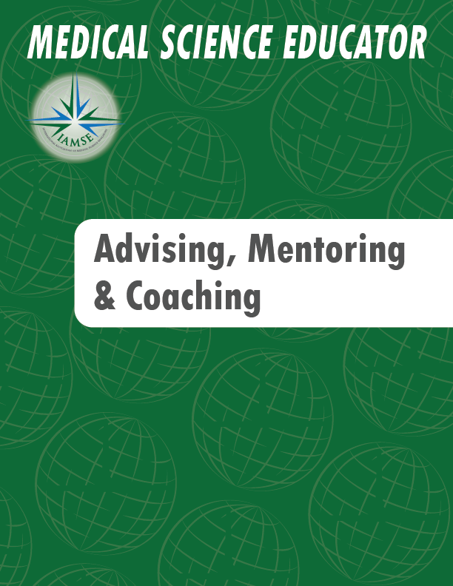
EXCELLENCE IN ADVISING, MENTORING, AND COACHING
Instructions: Use this worksheet to reflect and collect examples of your own work. If your institution does not provide a portfolio template, this worksheet can be used to create your own portfolio. To complete, remove the sample text and fill with your own examples. This form may be used to describe a single example of coaching, advising, or mentoring in great detail, or multiple coaching, advising or mentoring activities.. These instructions can also be deleted at any time.

DESCRIPTION
ADVISING/MENTORING/COACHING ACTIVITY  - Informal  - Formal  - Student interest group advising  - Peer advising  - Role modeling  - Career mentor/advisor/coach  - Research mentor/advisor/coach  - Educational mentor/advisor/coach  - Interprofessional education mentor/advisor/coach  - Professional society mentor/advisor/coach | - I served as a formal mentor to a junior faculty member in my department.  - I served as an advisor for the student cardiology interest group.  - I served as a mentor to three students in my research lab.  - I served as a mentor to new members at the national TBL conference.  - I served as a skills coach for two nursing students learning phlebotomy.  - I served as a coach for a medical student with repetitive lapses in professionalism.  - I served as an academic coach for a first year medical student struggling with organization and time management.  - I served as a coach for a colleague who was developing a series of new TBL sessions.
TYPE OF ADVISEE OR MENTEE OR COACHEE  - Student  - Faculty/colleague/peer  - Community member  - Other | - Second year nursing students in my research lab  - New early career faculty member in my department  - A peer from another institution  - First year physician assistant students
MY GOAL AS A MENTOR, ADVISOR, OR COACH  - Development of mentee, advisee, or coachee  - Advancement of mentee, advisee, or coachee  - Other | - While mentoring students in the lab, my goal was to guide their growth and development as in the responsible conduct of research.  - While mentoring an early career faculty member in my department, my goal was to make him aware of the criteria for promotion at an early stage, so he could work towards achieving those criteria. I also served as a resource for him as questions arose.  - While advising a peer for teaching, my goal was to help her to understand the high yield topics and master the content in a way that could be clearly relayed to the learners.  - While coaching a student with professionalism concerns for timeliness, I helped her identify the underlying problem and worked with her to develop the habits to achieve the goal of arriving early for required events.

SCHOLARLY APPROACH
INFORMED PREPARATION  - Consulted literature  - Read book(s)  - Attended faculty development session  - Attended webinar  - Attended conference  - Completed a certificate program  - Other specialized training  - Other | - I read two mentorship/advising/coaching books that focused on mentoring and used what I learned to develop a mentoring contract between an early career faculty member and myself.  - I earned a certificate in mentorship/advising/coaching from the AAMC and have applied what I learned to help advance the development of other faculty in my department.  - I explored the literature on coaching in the fields of business and sports and applied the broad lessons to health sciences education.
DEVELOPMENT OF ADVISING/MENTORING/COACHING PLAN  - Facilitation of mentee/advisee/coachee goal development  - Facilitation of mentee/advisee/coachee goal achievement through a specific framework  - Other | - After reflecting on my ability and willingness to be an active participant in the mentoring process (initiation phase), my mentee and I developed a mutual agreement and action plan for our mentor-mentee relationship (building phase), then met monthly for a year to work towards the goals outlined our agreement (sustaining phase).  - After a year, once my mentee achieved the goals outlined in our agreement, we redefined our relationship as colleagues (disengaging phase).  - I worked with a variety of peers who provide advising and support to medical students to develop a standardized longitudinal advising program with advising milestones for each curricular year.  - I have developed a coaching program for all faculty in my department who are preparing for promotion in the current academic year.
OUTCOMES AND EVALUATIONS  - Scope of relationship  - Duration of relationship  - Evidence of advisee/mentee/coachee success  - Other | - The student I mentored presented her research as a poster at a national meeting.  - The early career faculty member I mentored was promoted.  - The PhD student I mentored received three job offers.  - The department has now instituted mentoring committees that meet regularly based on the success of my mentoring experience.  - The colleague whom I coached on TBL methodology has developed a TBL module that has positive student evaluations.
MY REFLECTIVE CRITIQUE  - Reflective journal  - Solicited peer feedback  - Solicited mentee/advisee/coachee feedback  - Planned for future directions  - Other | - Following each meeting with my mentee, I kept a reflective journal on what went well and what I could have done better. I used this reflection to approach problems in a different way.  - At the end of each academic year, I met with the cardiology student interest group and asked how I could have served them better in my advising role. This feedback has improved my role as an advisor.  - I talked with my own mentor when I had a problem with my mentee that I did not know how to resolve.  - After coaching a number of students on skills development for phlebotomy, I reviewed my process and consulted the literature, which allowed me to streamline the coaching process.

SCHOLARSHIP/DISSEMINATION
DISSEMINATION  - Peer-reviewed  - International  - National  - Regional/Local  - Internal peer review only  - Invited dissemination  - International  - National  - Regional/Local  - Dissemination Type  - Publication  - Oral presentation  - Poster presentation  - Scholarship metrics such as cites, downloads, presentation evaluations are available  - Other | - I created a novel mentoring contract that was peer-reviewed and accepted for presentation at the annual IAMSE meeting.  - I published an original research article on the impacts of coaching for peer-evaluation in medical education.  - I was invited to present a faculty development workshop on the distinct roles of advising, mentoring, and coaching  - I created a regional mentoring program for physiologists in medical education and recruited 20 faculty members from 6 schools to participate.  - I developed the advising guidelines for student interest groups at my school and presented it at the annual AAMC meeting on student advising.  - I published a scoping review about the utilization of coaching in health sciences education in a peer-reviewed journal  - I was invited by a journal editor to write an editorial on coaching in the clinical environment.

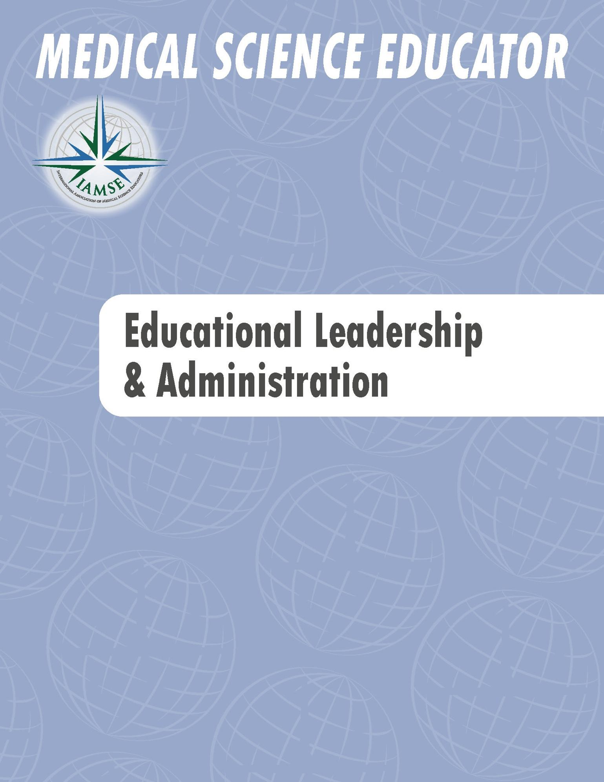
EXCELLENCE IN LEADERSHIP AND ADMINISTRATION
Instructions: Use this worksheet to reflect and collect examples of your own work. If your institution does not provide a portfolio template, this worksheet can be used to create your own portfolio. To complete, remove the sample text and fill with your own examples. This form may be used to describe a single example of leadership and administration or several examples. These instructions can also be deleted at any time.

DESCRIPTION
ROLE  - Course director  - Clerkship director  - Discipline/thread/strand  - Director  - Residency program director  - Department chair  - Institutional committees  - Task Force chair  - Position in local, regional, national or international organizations or societies  - Elected  - Appointed  - Other | - I served as director of the Gastrointestinal Systems course in the second year of the undergraduate medical education program.  - I was elected to serve as a chairperson for the membership committee of the International Association of Medical Science Educators (IAMSE).  - I was appointed as vice-chair of the curriculum committee.  - I was elected to represent my department on the faculty academic council.  - I was invited by my dean to chair a task force for DEI in medical education.
TARGET AUDIENCE  - Students  - Staff  - Faculty  - Administration  - Colleagues  - Members of an institutional committee  - Members of an organization or Society  - Other | - I created a course targeted to nursing students in the second year.  - As chairperson of the membership committee for IAMSE, I served faculty and student members of the International Association of Medical Science Educators (IAMSE).  - I represented faculty educators at my home institution (both employed and contracted faculty) on the faculty academic council.
NUMBER OF PEOPLE IMPACTED  - Number of people per year  - Number of years involved  - Other metric of programmatic reach | - 124 students are enrolled in the course each term.  - Twelve members on the membership committee serve approximately 1,200 members of IAMSE.  - I represented 26 faculty members within the department.  - The DEI orientation program was adopted by my department and then by the school and several affiliate hospitals.
DESCRIPTION (cont.)
GOAL(S)  - Curricular leadership  - Accreditation  - Diversity, Equity, Inclusion  - Faculty Development  - Serve the mission of an organization or society  - Obtain funding  - Develop best practices  - Support an institutional committee  - Other | - To coordinate interdisciplinary faculty for teaching in the gastrointestinal course and aid in their integration of material.  - The Committee for the Advancement of Medical Science Educators (CAMSE) was created to identify ways to enhance the appreciation and recognition of medical science educators.  - The major goal of the faculty academic council was to represent the voice of the faculty to members of the Dean’s cabinet.  - The goal of creating the teaching academy was to promote the educational mission of our institution.  - We required our chairs to report on the faculty development provided to their faculty.  - Our department had 100% faculty attendance at DEI orientation training.
MY ROLE, DURATION and SCOPE  - Leader  - Organizer  - Chair  - Co-chair  - Director  - President  - Vice-President  - Other | - As a leader, I was responsible for the overall design of the course, including the development of learning objectives, instruction, and assessment (2010-current).  - My co-chair and I were responsible for creating the subcommittee, drafting the mission statement, and selecting and appointing members to the committee.  - In my role as the retreat organizer, I assembled a small team of faculty academic council members to design the half-day annual retreat, which included identifying an outside speaker, drafting the retreat agenda, and working out the retreat logistics.
RESOURCES UTILIZED  - Structural (processes for implementation, evaluation, and allocation)  - Budget  - Grants  - Human resources  - Political (involvement of stakeholders)  - Other | - I recruited biomedical and clinical science faculty to participate in the course.  - I worked closely with members of the IAMSE management company during this project. Together, we developed the budget, planned the meeting, and created an evaluation system for different faculty development sessions at the meeting.  - I engaged the associate dean for Faculty Affairs in order to obtain funding for the team-building exercises during the retreat.
SCHOLARLY APPROACH
INFORMED PREPARATION  - Consulted literature  - Reviewed instructional texts  - Completed faculty development  - Consulted experts  - Consulted best practices models  - Consulted national guidelines  - Other | - To aid in the design of the course, I consulted the NBME content guide, engaged with colleagues running similar courses at their own institutions, engaged the discipline directors at my home institution, and selected five key faculty involved in the course to serve on the course committee.  - The members of CAMSE conducted a literature review to determine what was known about medical educators’ understanding of institutional processes for evaluating faculty for promotion/tenure. We identified a gap in the literature and decided to survey the IAMSE membership. To aid in the design of the questionnaire, I took the AAMC MERC Questionnaire Design and Survey Research Workshop  - The faculty academic council conducted a review of faculty handbooks from the other medical schools in the state before we began the most recent edit of our own faculty handbook.
DEVELOPMENT OF LEADERSHIP OR  ADMINISTRATION PLAN  - Conducted a needs assessment  - Developed and executed a timeline with milestones and deliverables  - Considered logistics and stakeholder endorsement  - Selection and development of a diverse team  - Leadership skills development  - Other | - An outcome logic model was created to aid in the design of the course to anticipate required inputs (resources).  - A course committee was assembled to include both basic science and clinician educators and members of the major biomedical science disciplines taught in the course (e.g., anatomy, microbiology, pharmacology, etc.).  - I attended the AAMC Leadership and Management Foundations for Academic Medicine and Science course to improve my leadership skills.
OUTCOMES AND EVALUATIONS  - Institutional evaluations  - Program evaluation by educational consultants/expert reviewers  - Adoption by other institutions or organizations  - Improved outcomes  - Awards  - Letters or other forms of communication that recognize your contributions  - Grants  - Other | - The gastrointestinal course was evaluated by students, the course director, and the course committee. As a result, the events in the course were sequenced to create a more logical flow and to reduce redundancy within events. The results of this new sequencing were presented to the curriculum committee.  - The members of the CAMSE committee created a questionnaire that was sent to the IAMSE membership. The results were published in Medical Science Educator.  - There were several important outcomes from the faculty academic council, the most important of which was the implementation of a needs assessment for all faculty.
SCHOLARLY APPROACH (cont.)
MY REFLECTIVE CRITIQUE  - Reviewed evaluations  - Reviewed assessments by educational consultants/expert reviewers  - Peer consultation  - Planned for ongoing improvement  - Other | - After reviewing the student course evaluations, I moved the pathology content earlier in the course and increased the number of active learning sessions by adding four case-based learning sessions.  - The results of the CAMSE survey suggest a need for IAMSE recommended resources targeted to faculty preparing for promotion and for those institutional officials charged with promotion/tenure decisions. We have begun a second phase of our work to create concise toolkits, one for educators and one for evaluators.  - To address faculty engagement, an issue identified by the faculty academic council, the council has modified the schedule and agenda of evening faculty meetings.
SCHOLARSHIP/DISSEMINATION
DISSEMINATION  - Invitations to participate or lead task forces  - Invitations for educational consulting (internal and external)  - Invitations to present at  - local/regional/national/international meetings or conferences  - Major institutional awards  - Awards from national or international societies or organizations  - Adoption by other institutions or groups leading to organizational change experts and/or professional agencies  - Peer-reviewed dissemination  - International  - National  - Regional/Local  - Scholarship metrics such as cites, downloads, presentation evaluations are available  - Other | - Based on extensive analysis of course assessment data, we published a “Twelve Tips” article in Academic Medicine. The article outlines tips for course analysis and revision.  - The results of the CAMSE survey were published in Medical Science Educator, a peer-reviewed journal of IAMSE.  - The faculty academic council executive committee now has standing monthly meetings with the dean to identify and collaborate on shared goals. We have drafted a Perspectives article we plan to submit to Academic Medicine. The article shares critical insights from faculty academic council executive committee members about how they worked to establish a meaningful relationship with the administration of our institution.  - I have been invited to consult at another medical school to help them create a systems-based curriculum.  - I was invited to chair the education committee of the national pharmacology society.  - I led a workshop on managing a discipline across an integrated curriculum at an international meeting for medical educators in 2017.

Simpson D, Fincher RM, Hafler JP, Irby DM, Richards BF, Rosenfeld GC, Viggiano TR. Advancing educators and education by defining the components and evidence of educational scholarship. Medical Education. 2007. (41) 1002-1009.

