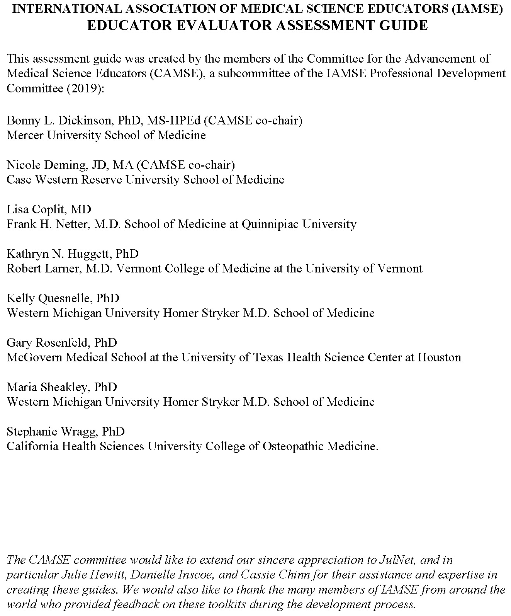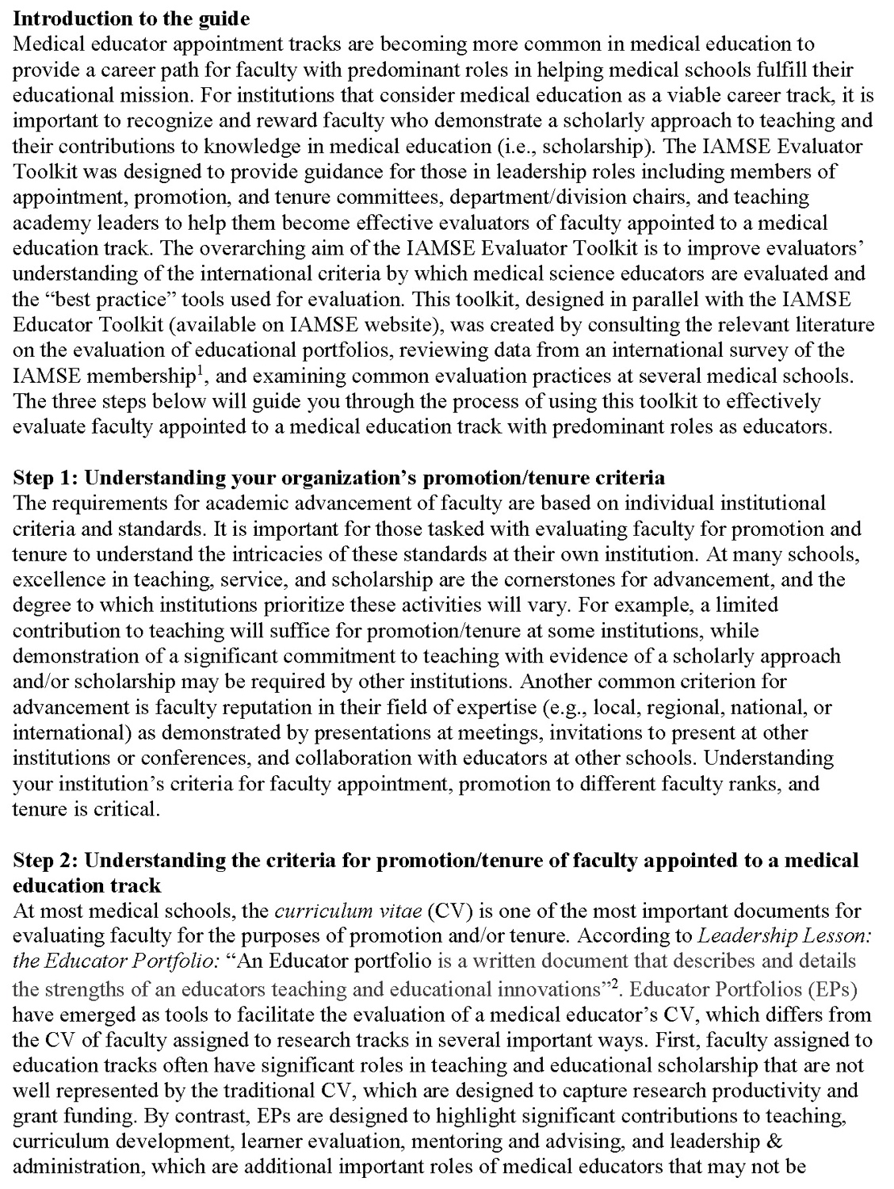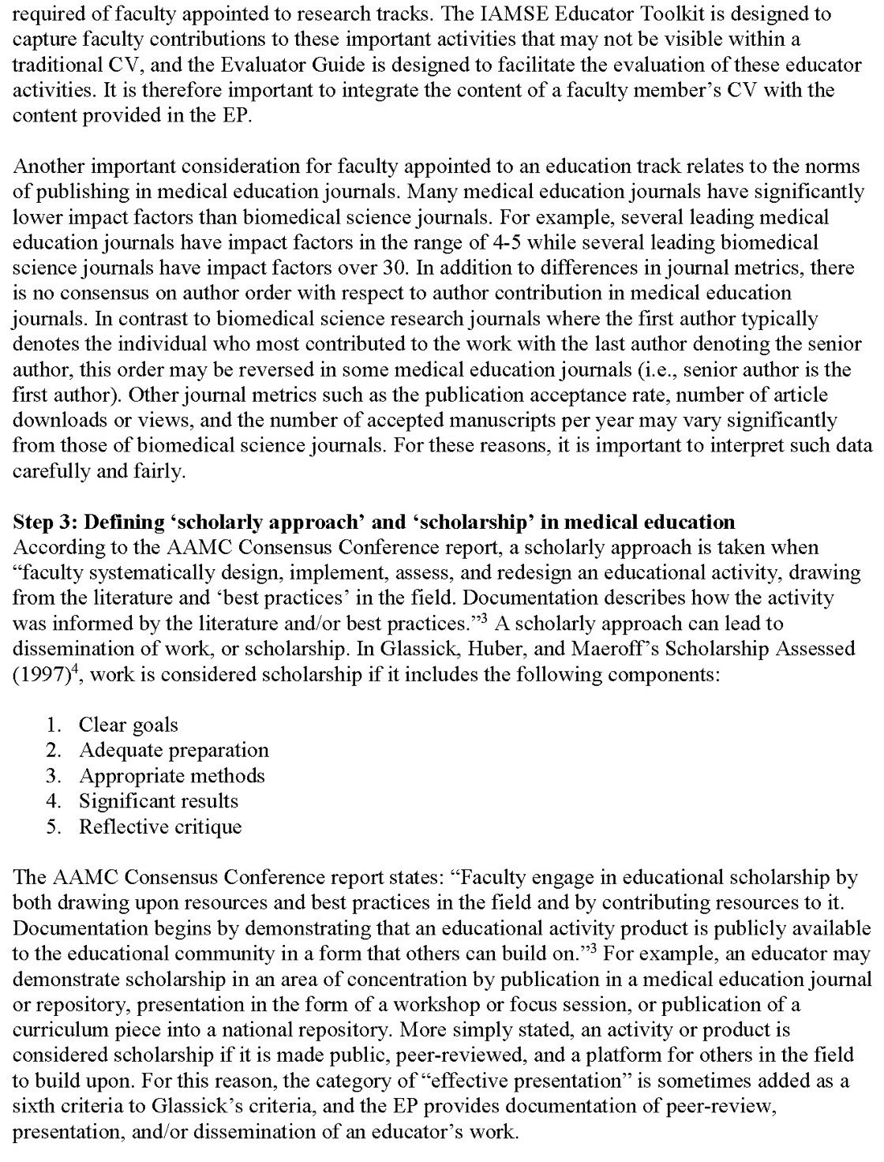

International Association of Medical Science Educators (IAMSE) Educator Evaluator Assessment Guide

Name of Educator for Promotion or Tenure:

Promotion Track (Assistant, Associate, Full):

Reviewer (your name):

Date of Review:

Standards and Criteria for Promotion
Add your institution’s criteria for the educators’ promotion track here

How to use this worksheet:
Use the three rating categories described below to evaluate the educator in each of the five domains of educator activities: teaching, learner assessment, curriculum development, advising and mentoring, and educational leadership and administration. For a more detailed description of these activities, refer to the worksheets in the Educator Toolkit.

- Description – The educational activity is clearly described and goals are well defined. The role of the educator is clearly stated. You are able to determine who, what, when, where, how often and how much time is devoted to the activity. There is evidence of significant dedication of time and effort to the activity.

- Scholarly Approach – The educator uses a scholarly approach to guide the design and development of educational activities. The educator uses an informed approach to developing all aspects of the activity (e.g. learning objectives, instructional methods, etc.). The educator assesses the activity and ideally, demonstrates improved outcomes. A process for continuous improvement using evaluation and reflection is evident.

- Scholarship/Dissemination – An educator may demonstrate scholarship in his/her area of expertise through peer review and dissemination of educational contributions to the larger educational community. Forms of dissemination include, but are not limited to, publication in journals, books, or online collections; presentation in the form of a workshop at a regional, national, or international meeting; adoption of one’s work by another department or institution; or acceptance of an educational product into a national repository such as MedEdPORTAL. Only “accepted” publications/presentations should be considered.

Teaching
Teaching is any activity that fosters learning. Educators may engage in teaching by giving lectures, facilitating small group discussions or lab groups, teaching on clinical rounds, etc. In this category, educators should document the quantity and quality of their teaching, their specific role(s), a scholarly approach to the process of teaching, and any dissemination of work in the domain of teaching.

Rating Category | Supporting Evidence
 | Insufficient | Sufficient | More than Sufficient | Unable to Assess
Description | ☐ | ☐ | ☐ | ☐
Scholarly Approach | ☐ | ☐ | ☐ | ☐
Scholarship/Dissemination | ☐ | ☐ | ☐ | ☐
Comments:

☐ Meets criteria for promotion based upon this category
☐ Does not meet criteria for promotion based upon this category
☐ Requires further discussion

Learner Assessment
Learner assessment is defined as all activities associated with measuring learners’ knowledge, skills, and attitudes. To assess excellence in this category, educators are asked to describe how they developed, implemented, analyzed, and synthesized an assessment project, including any dissemination of work in the domain of learner assessment.

Rating Category | Supporting Evidence
 | Insufficient | Sufficient | More than Sufficient | Unable to Assess
Description | ☐ | ☐ | ☐ | ☐
Scholarly Approach | ☐ | ☐ | ☐ | ☐
Scholarship/Dissemination | ☐ | ☐ | ☐ | ☐
Comments:

☐ Meets criteria for promotion based upon this category
☐ Does not meet criteria for promotion based upon this category
☐ Requires further discussion

Curriculum Development
Curriculum development refers to the creation of a longitudinal set of educational activities and is to be differentiated from creation of a single educational event. Examples may include a basic science lecture series, a set of clinical reasoning cases, a series of clinical skill workshops, faculty development workshops, etc. A curriculum must have goals, teaching methods appropriate for those goals, an informed approach to the design, a means of assessment of its effectiveness, and ongoing improvement based upon the evaluation results. In this category, the educator is asked to describe each of these aspects of the curricula they have developed and any dissemination of work in the domain of curriculum development.

Rating Category | Supporting Evidence
 | Insufficient | Sufficient | More than Sufficient | Unable to Assess
Description | ☐ | ☐ | ☐ | ☐
Scholarly Approach | ☐ | ☐ | ☐ | ☐
Scholarship/Dissemination | ☐ | ☐ | ☐ | ☐
Comments:

☐ Meets criteria for promotion based upon this category
☐ Does not meet criteria for promotion based upon this category
☐ Requires further discussion

Advising and Mentoring
An advisor serves an advisee in a focused capacity to help him/her with a decision or course of conduct, or to provide suggestions for a specific project. A mentor helps a mentee to achieve his/her personal and professional goals by providing guidance, support, and the creation of opportunities for the mentee. This requires an ongoing, committed relationship with clear goals to help the mentee achieve their own definition of success. Assessing the quality of an educator’s contribution in this category means determining whether the advisor/mentor has helped the learner meet defined goals. In this category, the educator is asked to describe their role in facilitating advises/mentees success and asked to provide evidence of a scholarly approach to this important means of teaching, and any dissemination of work in the domain of advising/mentoring.

Rating Category | Supporting Evidence
 | Insufficient | Sufficient | More than Sufficient | Unable to Assess
Description | ☐ | ☐ | ☐ | ☐
Scholarly Approach | ☐ | ☐ | ☐ | ☐
Scholarship/Dissemination | ☐ | ☐ | ☐ | ☐
Comments:

☐ Meets criteria for promotion based upon this category
☐ Does not meet criteria for promotion based upon this category
☐ Requires further discussion

Educational Leadership and Administration
Effective leaders in education transform educational programs and advance the field. They should seek ongoing excellence, evaluate outcomes, disseminate results, and maximize resources. To assess excellence in this category, educators are asked to describe the initiatives they have led in their roles, the impacts and improvements these initiatives have made, and any dissemination of work in the domain of educational leadership and administration.

Rating Category | Supporting Evidence
 | Insufficient | Sufficient | More than Sufficient | Unable to Assess
Description | ☐ | ☐ | ☐ | ☐
Scholarly Approach | ☐ | ☐ | ☐ | ☐
Scholarship/Dissemination | ☐ | ☐ | ☐ | ☐
Comments:

☐ Meets criteria for promotion based upon this category
☐ Does not meet criteria for promotion based upon this category
☐ Requires further discussion

Philosophy of Education and Long Term Goals
The educator adequately describes the principles that guide their work as an educator and their specific interests and career goals as an educator, including any professional development programs they have participated in to improve their work as an educator.

☐Agree
☐ Disagree
☐Unsure

Comments:

Overall Recommendation
☐ Meets criteria for promotion
☐ Does not meet criteria for promotion
☐ Requires further discussion

Comments about your overall recommendation:

