How to audio-record your PowerPoint presentation?
PGM de Jong, May 4, 2020
v

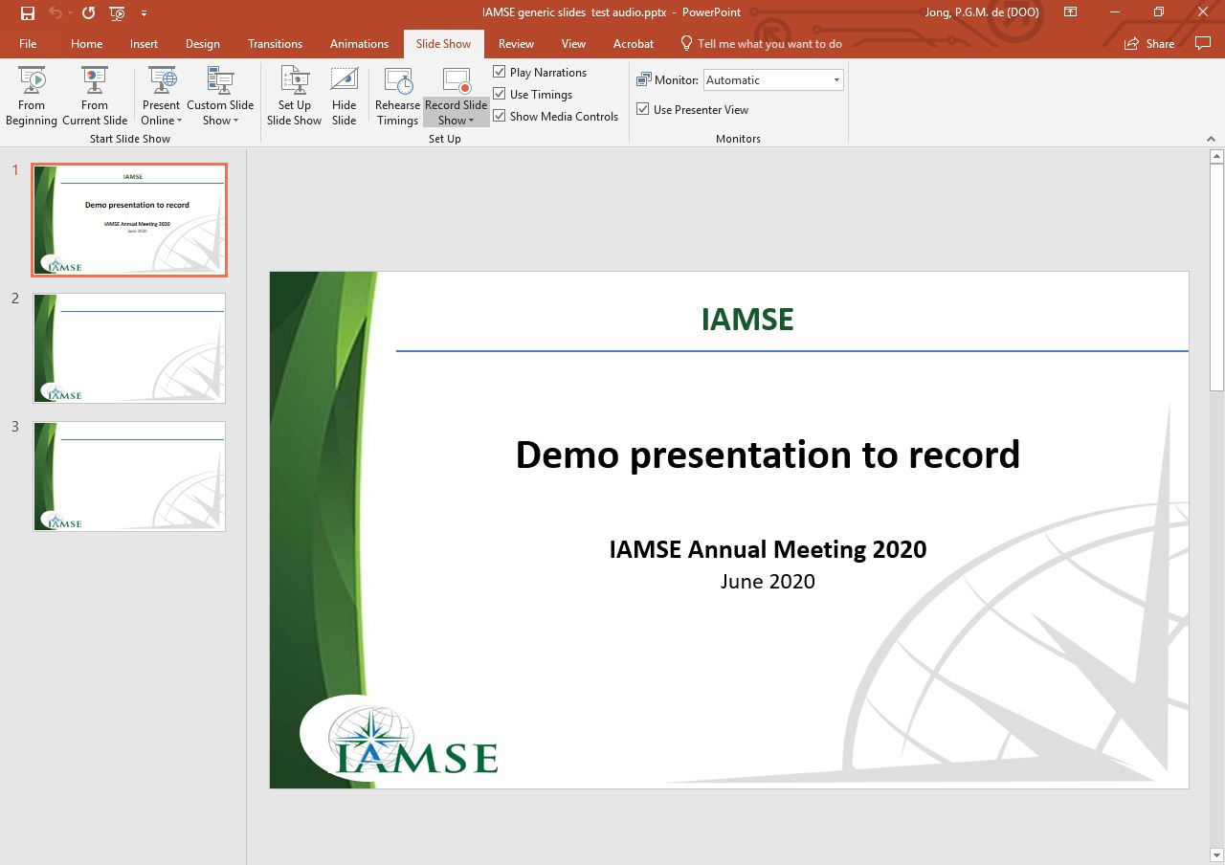
Create your PowerPoint presentation first.

- Animations are allowed and will be recorded.

- Do not embed video files.

To record your talk, follow these steps:

- Open your slide deck in PowerPoint.

- Go to the menu “Slide Show”.

- Select the option “Record Slide Show”.

Now you see the central dashboard for recording:
v

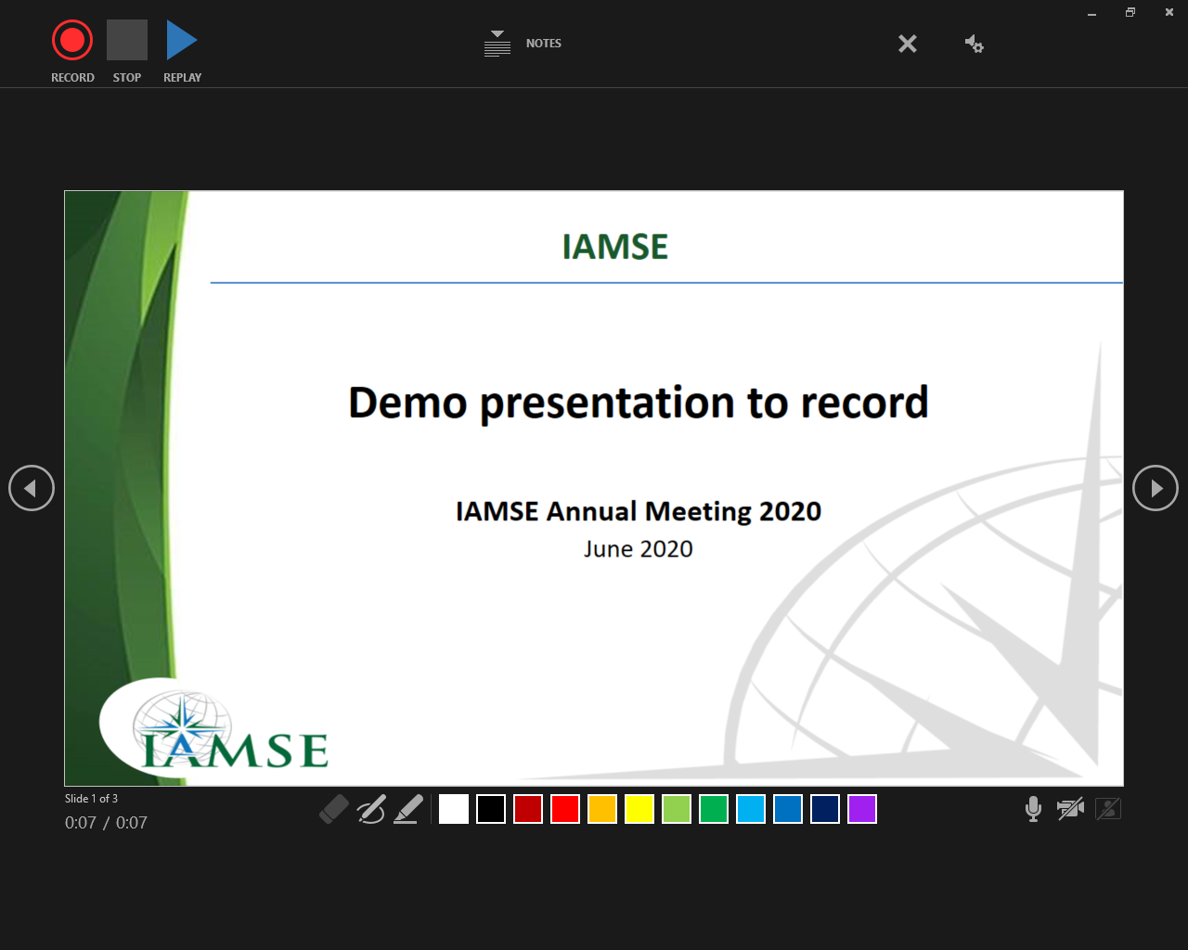
- In the right bottom, please disable the camera and enable the microphone. To keep the recording file small in size, you are only allowed to record audio!

- Make sure you are in a silent environment.

- To start recording, press the “RECORD” button in the left top corner.

- Recording starts after the 3 seconds countdown.

- Just present the talk by talking in the microphone and by advancing the slides as you are used to. Animations will also be recorded.

- Use the “STOP” button when you are finished.

- Close the window with the “x” in the right top corner.

- Now go to the menu “File” and select the option “Export”, and the option “Create a video”. Select the desired quality (Note: the better quality, the larger file!) and press the “Create video” button. Select your destination directory and filename to store. Click on “Save” and you are all set!

- You can now use the mp4 file to play your presentation.

